FH456-- How to setup Parental Control
Note: This article will guide you how to setup Parental Control and the steps as below.

Step 1: Connect your computer to the LAN port of FH456.Power on the FH456. 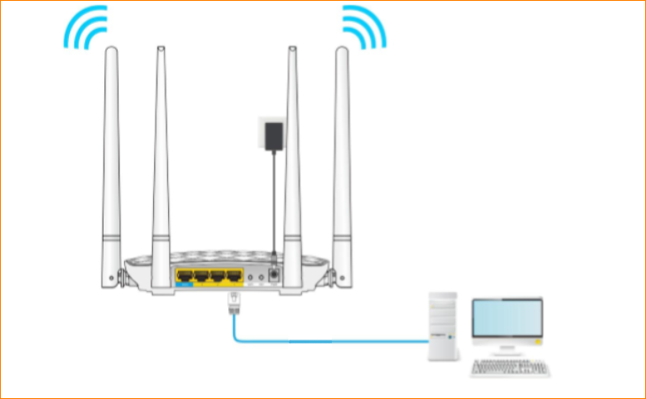
You can also use your smartphone to configure the router.
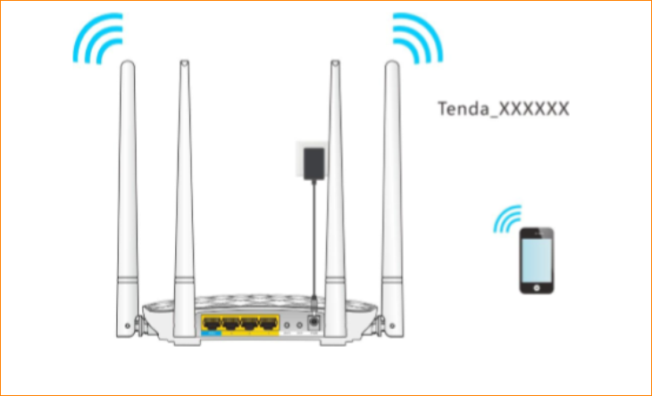
Step 2: Open a Web Browser -> Input http://tendawifi.com or 192.168.0.1 in the address bar -> Press Enter
Step 3: Go to Parental Control, choose the device you want to control, and then click the button.
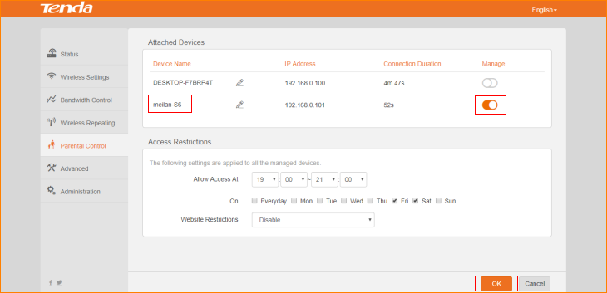
Step 4: Choose the device and set up when you allow it to access the internet and what websites that you allow it to access, and then click “OK”.
